**RAJAGURU STORES POS System**

**USER MANUAL**

**Table of Contents**

**Installation Help 3**

1. **Login Window 4**
2. **Main Window 6**
3. **Sub windows 11**
   1. Supplier Window 11
   2. GRN Window 13
   3. Products Window 13
   4. Stock Manage Window 11
      1. Stock Report Window 11
   5. Purchase Window 11
      1. Return Products Window 11
   6. Reports Window 11
      1. GRN Reports 11
      2. Transaction Reports 11
      3. Order Reports 11
   7. Notification Window 11
      1. Notification History 11
      2. Low Stock 11
      3. Expire Products 11
   8. Online Customer Details Window 11

**Login Window**

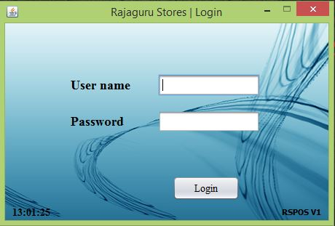

Here we have include the user login interface which make the user

to enter the system. There are to different kinds of users.

* Admin
* Non admin(employee)

So user has to input password and user name ,and he or she get correct password ,username can log to the system.

**Main Window**

**8**

**6**

**3**

**7**

**5**

**4**

**2**

**1**

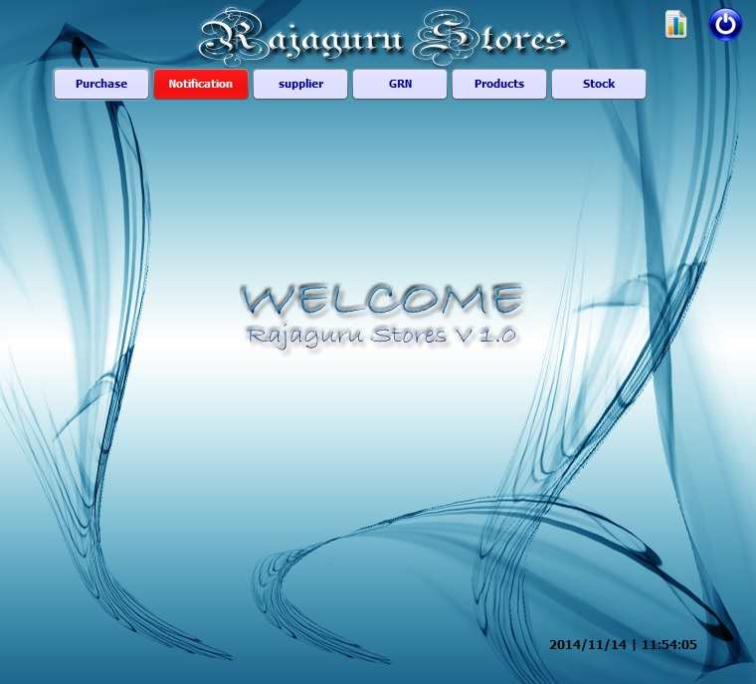

**10**

**9**

1-Purchase Window 6- Stock Management Window

2-Notification Window 7-Report Generating Window

3-Supplier Window 8-Log out Button

4-GRN Window 9-Date

5-Product Window 10-Time

**Sub Windows**

**8**

**7**

**Supplier Window**

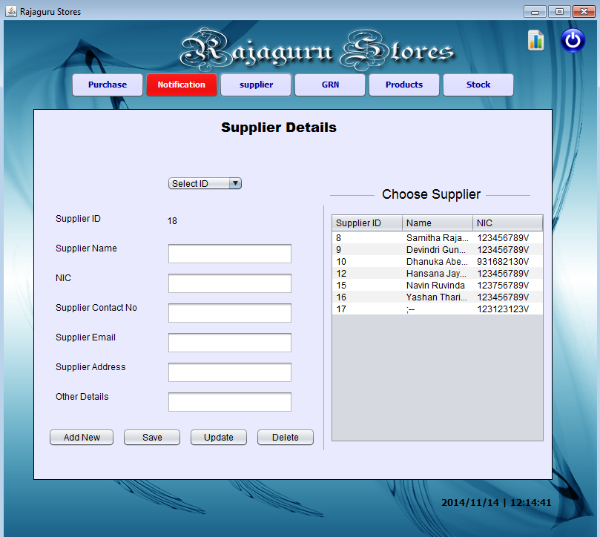

12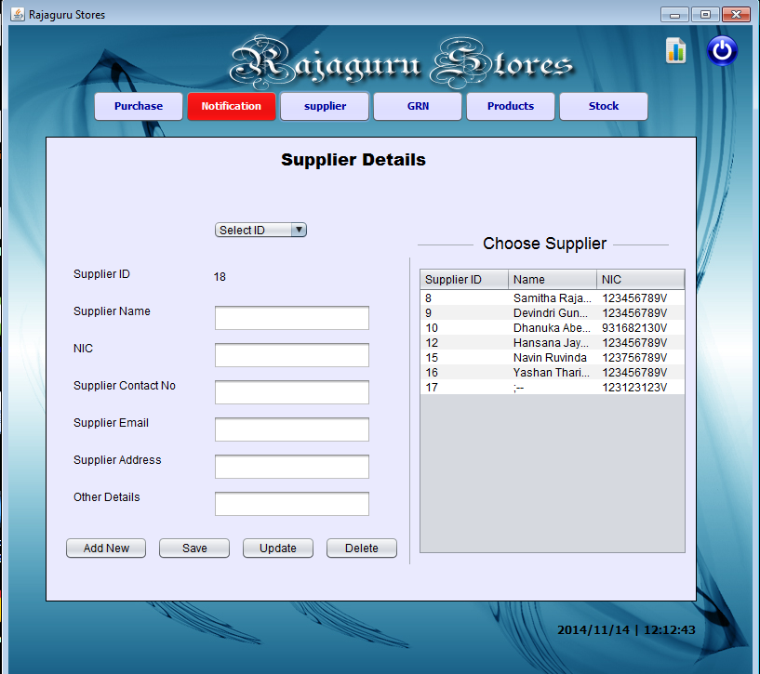

11

9

8

10

7

6

5

* 

1

2

3

4

13

1-Supplier ID 8-Add New Button

2-Supplier Name 9-Save Button

3-NIC 10-Select ID Button

4-Supplier Contact Number 11-Update Button

5-Supplier Email 12-Delete Button

6-Supplier Address 13-Choose Supplier Table

7-Other Details

* For add a new Supplier or Clear text fields press “Add new” button.
* The Supplier ID will be auto generated
* The user should manually insert the data and Press the “save” button.
* Registered supplier details load to the text boxes in the form automatically from the choose supplier table.
* The “Update” button will give the user the facility to update facts about current suppliers.
* User can remove a current supplier by the Delete button.

**Stock Handling**

12

11

10

9

8

7

6

5

3

3

2

1

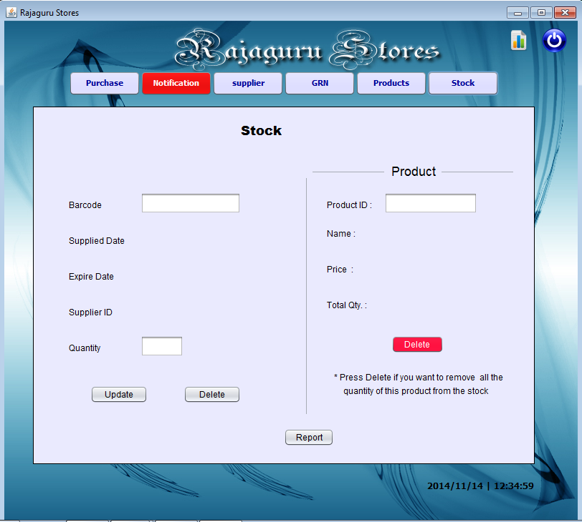

4

1-Barcode 7-Product ID

2-Supplier Date 8-Name

3-Expire Date 9-Price

4-Quantity 10-Total Quantity

5-Update Button 11-Product Delete Button

6-Delete Button (For an unique barcode) 12-Report Button

* The Barcode Number should be manually entered to update or delete in the quantity of stock.
* When a Barcode is entered the “Total quantity” of products, shows the total product quantity of that in the stock.
* The “update” button updates the product quantity of stock for the given product Barcode.
* “(6) Delete” button deletes the stock related to the barcode given.
* “(11) Delete” button removes the total quantity of the product in the stock related to the Product ID.
* Press the “Report” button to generate a report of current stock.

**GRN (Good Received Notes)**

8

10

9

7

6

5

4

3

2

1

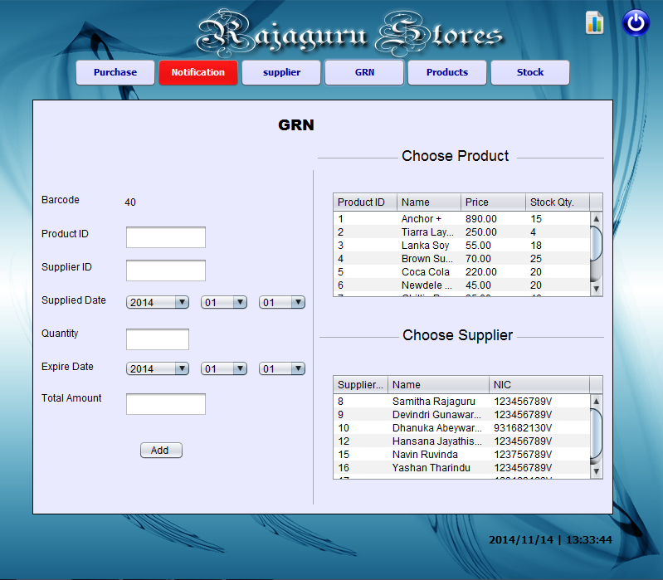

1-Barcode 6-Expire Date

2-Product ID 7-Total Amount

3-Supplier ID 8- Add Button

4-Supplier Date 9-Choose Product Table

5-Quantity 10-Choose Supplier Table

* The user can use this interface to insert the details to the system, when a supplier supplies good.
* When a product is supplied from different expiry dates from different suppliers or the same it’s been entered to the database with different Barcodes.

**Purchase Window**

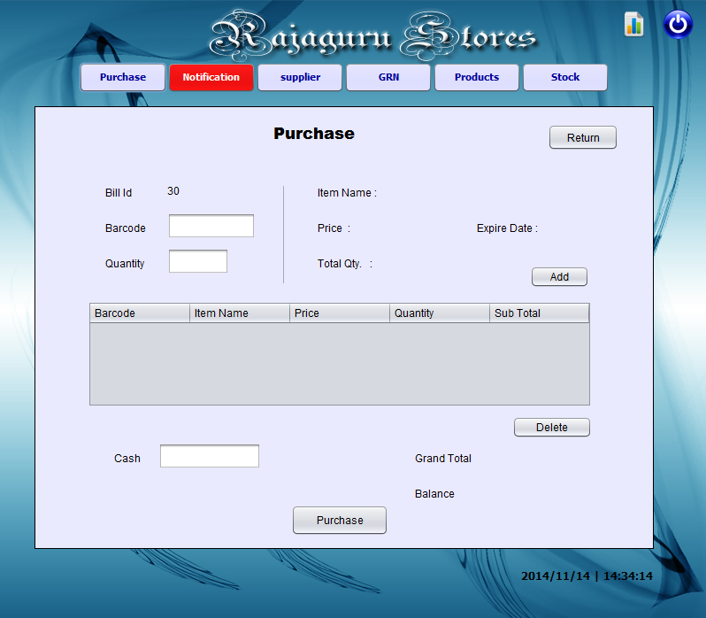

15

14

13

11

12

10

4

5

9

8

7

6

3

2

1

1-Bill ID 6-Item Name 11-Add Button

2-Barcode 7-Price 12-Delete Button

3-Quantity 8-Total Quantity 13-Grand Total

4-Billing Table 9-Return Button 14-Balance

5-Cash 10-Expire Date 15-Purchase Button

* This is the window that generates the Bill.
* The “Barcode” field is used to enter the barcode (number) given in the product.
* “Return” button is used to view the previous transactions

**Return Products Window**

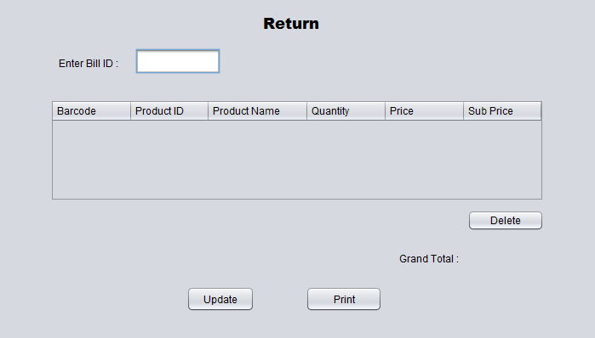

5

6

4

3

2

1

1-Enter Bill ID 3-Delete Button 5-Update Button

2-Goods Return Table 4-Grand Total

* To view an exciting bill, enter the bill id in “Enter Bill ID” field.
* To Update the Transaction, user has to select the relevant row and press the “Delete” button.
* By pressing “Update” Button, new Grand Total will be updated.

**Product Window**

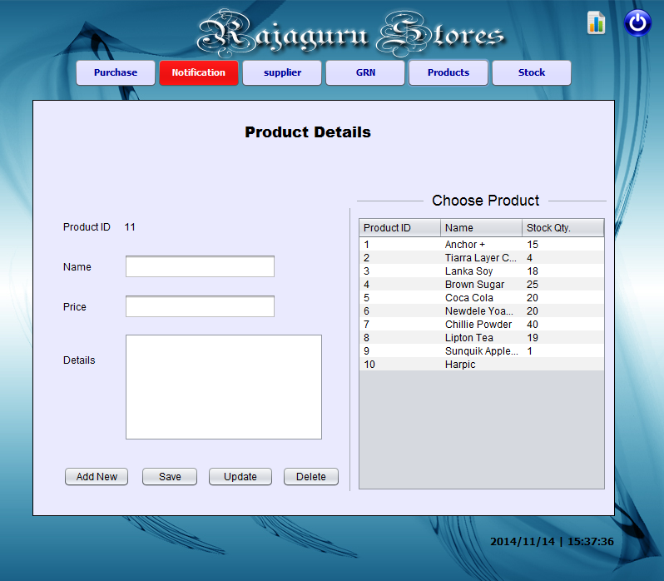

4

3

2

1

9

5

6

8

7

1-Product ID 4-Details 7-Update Button

2-Name 5-Add New Button 8-Delete Button

3-Price 6-Save Button 9-Choose Product Table

* Product Id Auto generates
* Name field is used to insert the product name.
* Price field to enter the product price.
* Product Details field to insert extra details.
* For add a new products or Clear text fields press “Add new” button.
* “Save” button saves the current inserted product information
* The “Update” button will give the user the facility to update facts about current products.
* User can remove a current product by the Delete button.
* Choose Product table shows the new products inserted.

**Notification Window**

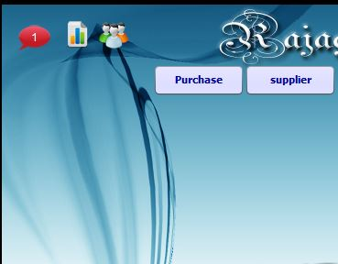

If user go messages or notifications before he enter the system

He will suddenly get the notification as mentioned above.

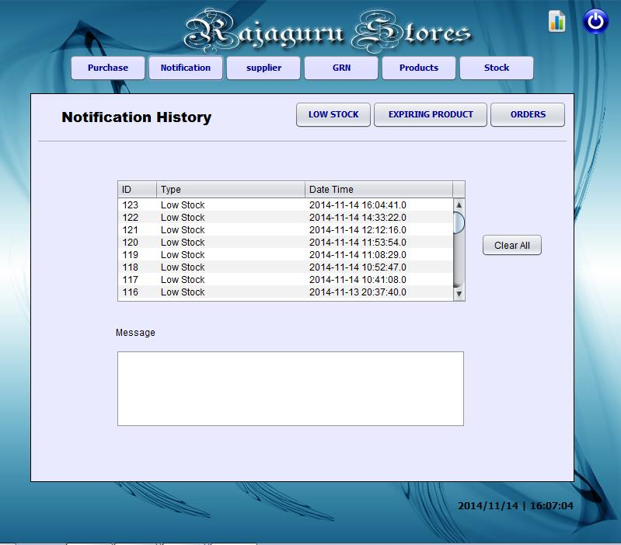

6

1

2

3

4

5

1-Notification Table 3-Expiring Button 5-Clear All Button

2-Low Stock Button 4- Orders Button 6-Message Box (If any)

* This is the interface which the user will receive after he clicks on the Notification button. The table which is shown in the above picture shows whether some product has come to its minimum stock, or the stock has come close to its expiry date, or a new order has come to the system.
* When the user clicks the Low Stock button the details of the relevant product will be shown.
* When the user clicks the Expiring button the details of the relevant product will be shown.
* When the user clicks the Orders button the details of the relevant order will be shown.

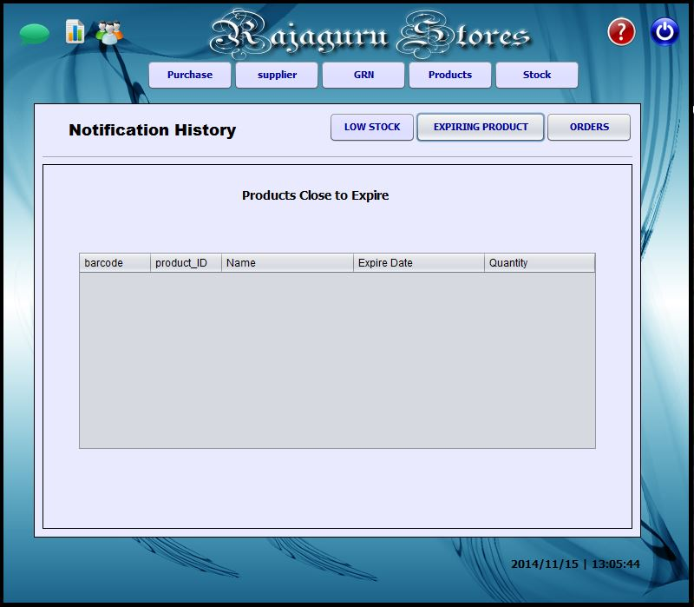

When the user want check the low stock he has to enter the notification window. In notification window user has three selective buttons.

Expiring product

Low stock

Order

So he must enter to the low stock window and he

Gets the low stock window like mentioned above.

**Reports**

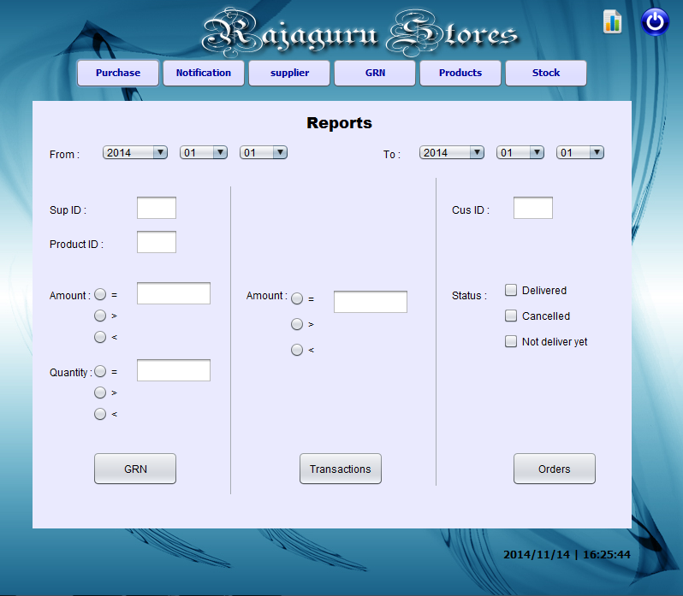

1-Starting Date 5-Quantity 9- Transactions Button

2-Supplier ID 6-GRN Button 10-Add Button

3-Product ID 7-Closing Date 11-Status

4-Amount 8-Amount 12-Orders Button

When the user clicks the GRN Button (6) all the records between the Starting Date (1) and the Closing Date (7) will be generated as a report. By filling the Supplier ID, Product ID, Amount, Quantity the user can get more specific data records.

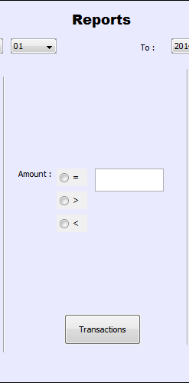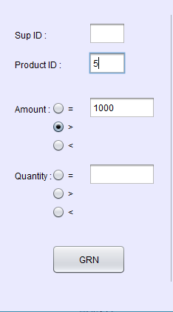As shown in this picture for an example the Product ID has been filled as 5 and the Amount has been filled as greater than amount 1000 between the selected dates. So then the user will get data according to these given inputs. A Report is Generated using these details with the when the GRN button is clicked.

Transaction Button Prints all the details related to the transactions within the given dates.

Amount field is used to indicate the specific transaction data needed to be printed.

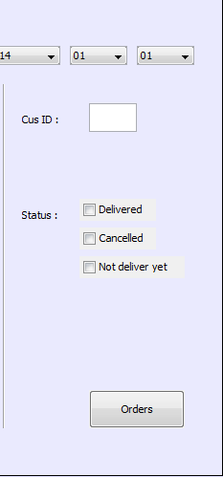When the user clicks the Orders Button (9) all the records between the Starting Date (1) and the Closing Date (7) will be generated as a report. If the user wants to get more specified information he/she can give the “Customer ID” and the “Status”.